August 5th, 2007
Hi
A number of anniversaries:
- tomorrow will be the 62nd anniversary of the dropping of the atomic bomb on Hiroshima.
- Leonie’s birthday yesterday.
- Gavin and Sians’ second wedding anniversary (somewhere about this time).

Last Monday I got back to work in HK. Also, back to exercise. Did a 15 min skip but it was a bit tough having not done any for about 10 days. Followed this with a 1.2 km swim. On Tuesday, I did weights in gym, the first time for about 2 months. I decided to do swimming as long as the weather was fine and do weights when the weather was bad and the pool was closed. Well, we have had fine weather for nearly 2 months, with fine, cloudless skies, low air pollution but very hot. The other day the official temperature at the Observatory reached 35.3⁰C though it was hotter in other areas. The reason is due to an area of high pressure covering HK and stretching all the way to the Philippines that is just sitting there. Because the air pressure is high, it blows everything else away, including storms and all the air pollution that comes in the other direction from China. That might also explain why there have been no storm/typhoon signals and why all the typhoons at this time are battering Japan.

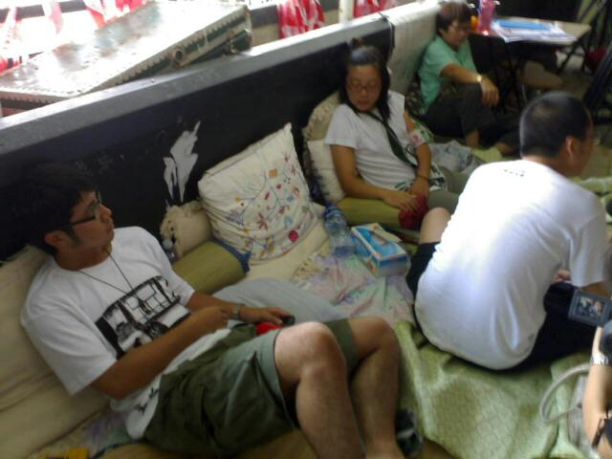

On Wednesday, the protest over the demolition of Queen’s Pier finally ended with the Police removing the remaining protesters who resisted the eviction orders. Quite a number of people had been camping out there as part of the protest. The government will now disassemble the pier, store it, and reassemble it somewhere later, in a place that is still to be decided.

Nadine, all the MIN TIES you brought me from Australia are now gone. I ate the late one the other day. Oh well, they contain trans fats anyway!
On Thursday, I went again to the dermatology clinic. Nothing new, though I thought I would get the cryo (liquid nitrogen) treatment for the patch on my nose.
My breathing has not been so bad after returning from Singapore. Although I take the steroid inhaler once a day (for long-term treatment), I have not taken the reliever inhaler once, though it has been close several times. I have transferred all the woollen blankets and bed covers stored under the bed to the cupboard above the fridge and all the things from the cupboard to under the bed. All the bed covers may have been dusty and a bit mouldy. I could smell dust and mould in the air and this may have been causing breathing problems. I also washed one of the sheepskin rugs a few weeks ago. The other (the white one) is in the bath now.

That seems to be it for now.
Cheers

